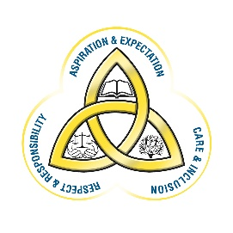

School Calendar
Monday 2nd September 2019: STUDENTS: Period 1-5
Monday 30th September 2019: STAFF DAY
Friday 25th October 2019: ALL STUDENTS PRESENT 8.50AM-11.45AM. YEAR 12 AND 14 STUDENTS REMAIN FOR PARENTAL CONSULTATION PM
Monday 28th October – Friday 1st November 2019: MID TERM HOLIDAY
Monday 4th November 2019: STAFF DAY
Monday 23rd December 2019 – Friday 3rd January 2020: CHRISTMAS HOLIDAY
Friday 17th January 2020: PARENTAL CONSULTATION FOR YEARS 8 & 9 ONLY THESE STUDENTS SHOULD ATTEND WITH THEIR PARENTS/CARERS
Thursday 13th February 2020: PARENTAL CONSULTATION FOR YEARS 11 & 13 ONLY THESE STUDENTS SHOULD ATTEND WITH THEIR PARENTS/CARERS

Friday 14th February - Friday 21st February 2020: MID TERM HOLIDAY
Monday 24th February 2020: STAFF DAY
Friday 13th March 2020: ALL STUDENTS PRESENT 8.50AM-11.45AM. YEAR 10 STUDENTS REMAIN FOR PARENTAL CONSULTATION PM
Monday 16th March - Tuesday 17th March 2020: HOLIDAY
Friday 10th April - Friday 17th April 2020: EASTER HOLIDAY
Friday 8th May 2020: HOLIDAY
Monday 25th May 2020: STAFF DAY
Tuesday 30th June 2020: LAST DAY
Parent Teacher Consultations on the following dates:
- Years 12 & 14: Friday 25th October 2019 from 12.30pm -3pm
- Years 8 & 9: Friday 17th January 2020 from 9am-11.45am and 12.30pm-3.00pm
- Years 11 & 13: Thursday 13th February 2020 from 9am - 11.45am and 12.30pm-3.00pm
- Year 10: Friday 13th March 2020 from 12.30pm-3pm

*Please note students are not required to attend school on staff days

